LIGO Laboratory / LIGO Scientific Collaboration

LIGO- T2400425-v2 Cosmic Explorer (CE) 10 Dec 2024

Convolution UHV Leak Failure Rate Estimate
LIGO Laboratory, CE Team
Dennis Coyne

Distribution of this document:
LIGO Scientific Collaboration

This is an internal working note
of the LIGO Laboratory.

California Institute of Technology  LIGO Project | Massachusetts Institute of Technology  LIGO Project
LIGO Hanford Observatory | LIGO Livingston Observatory
http://www.ligo.caltech.edu/

Table of Contents
1 Introduction 3
2 LEP 4
3 CE 5
4 LIGO 6
5 JET 6
6 GEO600 6
7 UHV Leak Failure Modes 7
7.1 Fatigue induced cracking 7
7.1.1 Bellows (expansion joint) 8
7.1.2 Corrugated Tube 10
7.2 Stress Corrosion Cracking (SCC) 10
7.2.1 Convolution Residual Stresses 11
7.2.2 LIGO Bellows 14
7.3 Microbial Induced Corrosion (MIC) 14
8 Reliability 15
9 Conclusions 15
10 Recommendations 15

List of Figures
Figure 1 Comparison of Fatigue Curves for Austenitic Stainless Steel: EJMA-1993 vs ASME-2023 8
Figure 2 Crack growth rate vs. stress intensity factor for non-sensitized steels in oxygenated pure water at 288C. 11
Figure 3 Residual stress distribution²⁵ after hydroforming the bellows (stress unit is Pa) 13

List of Tables
Table 1 LEP vacuum bellows failure rates 4
Table 2 LIGO Bellows Movement specified by CBI 8
Table 3 LIGO Bellows Stress 9

Introduction
The Cosmic Explorer (CE) and Einstein Telescope (ET) projects are considering the use of corrugated, thin-walled, tubing for their beam tubes as an alternative to thick-walled, smooth, straight piping or ring-stiffened piping (for a number of reasons; see for example LIGO-T2400337). The unstiffened and ring-stiffened tubes require bellows (expansion joints) to allow for expansion during vacuum bakeouts, as well as adjustments for alignment. The corrugated tube alternative does not require these discrete bellows (expansion joints) since they are (in effect) long bellows.
The convolutions are typically formed by either mechanical expansion or hydroforming. In either case, deep-drawing induces high plastic strains, which result in significant amplitude, residual, tensile stresses. Both bellows and corrugated tubes require weld seams. Welding can also result in significant residual tensile stresses in the Heat Affected Zone (HAZ). The HAZ is often the initiation site of microcracks (due to residual tensile stresses) leading to leaks later during the operational phase of the system.
Regardless of the method employed in forming the initial cylindrical shell (roll formed or spiral welded), axisymmetric convolutions will cross the weld. The high plastic strain conditions of convolution forming coupled with the HAZ can lead to crack initiation. Note that if the tube is spiral welded and also spirally corrugated, at the same helix angle, then the corrugations would not cross the weld.
The residual stresses and the cyclic movement (flexing) of the convolutions raises concern about the long-term reliability of the convolutions (whether in bellows or corrugated tubes). If the dominant leak failure mechanism is due to cyclic fatigue, then corrugated tubes are preferred (other issues aside) since the cyclic movement (and associated stresses) are spread over many more convolutions. However, if the dominant failure mechanism is SCC then smooth tubes with bellows is likely preferred in order to reduce the number/area of potential failure sites.
The onset of a Ultra-High Vacuum (UHV) leak on the order of 10E-9 Torr-L/s as a failure criteria is considerably more stringent than a structural failure of the vacuum envelope. As a consequence data and methods to predict lifetimes for structural failure may not be conservative enough for our application. Leak reliability data of bellows from some UHV projects are reviewed to give a very rough estimate of the leak reliability of corrugated tubes for CE and to motivate the reliability concern. (Bear in mind that the corrugation design and fabrication parameters though similar are not the same.) At this point in time the mechanism for UHV leak formation in convolutions (bellows or corrugated tubes) is speculative. As a consequence, the leak (failure) rate is also speculative. This comparison with UHV project data simply points out the need for more analysis/research, extensive testing, and more data from the UHV expansion joint (bellows) manufacturing sector, before committing to a CE beam tube design.

LEP
Bellows failure rate data for the LEP (Large Electron Positron collider) facility has been compiled. Unfortunately, the cause or specific location of the leaks were not identified in this paper or any of the source papers cited in this article. Neither were the details of the fabrication (e.g. the type of weld). However, one paper noted that after the LEP bakeout there were 3 failures of the welds on the bellows (although the specific location of these weld leaks, e.g. at flange, or at a convolution, were not identified). The parameters of the LEP standard vacuum bellows are as follows:
- 2,649 standard bellows units in use on the LEP
- circular cross-section, hydroformed convolution bellows with single plys
- each bellows had 10 convolutions and a 14-mm convolution height
- constructed of 316L stainless steel
- units were 0.168 m in length and 0.188 m in outer diameter
- thickness was 0.15 mm
LEP base vacuum was low 1E-8 Pa (8E-11 torr) range, which is lower than LIGO's base pressure of 1e-9 torr, but likely equal to CE's base pressure.
Tested bellows units gave an average lifetime of 25,000 cycles at bakeout temperature (150C), which is a factor of 100 above the design requirement. This overdesign is believed to be a factor in the high reliability performance of these LEP bellows units. The failure statistics are given in Table 1.
Table 1 LEP vacuum bellows failure rates
Note that the LEP small vacuum leak rate of 1e-5 Pa-L/s (7.5e-8 torr-L/s) is larger than LIGO's leak rate limits: 1e-10 torr-L/s at the component level and 1e-9 torr-L/s for each 2 km BT module.
Assuming that the leak location is associated with (scales with) the convolution number and using LEP's 5% lower bound on the leak failure rate per Bellows-Hour, gives a leak failure rate of 2e-9 per convolution-hour.
These LEP bellows are sealed with aluminum gaskets, not copper. However, the reported bellows failures do not involve the gaskets, according to Reference 1.
The LEP standard bellows are subjected to a 150C vacuum bakeout (wherein the bellows only reach 50C), requiring 37 mm compression for the 10 convolutions of each bellows). The bellows had a design requirement of 250 compression-expansion cycles at bakeout temperature. An additional design requirement was a life of 10,000 cycles of 6 mm stroke at room temperature. According to Cadwallader¹ (2010) the typical operating temperature of the walls was not cited in any of the references, so it was assumed to be close to room temperature, on the order of 15-20°C, but excursions to higher temperatures were possible – perhaps up to as high as 60°C (Bryan, 2009). According to Unterlerchner (1990) the LEP bellows lifetime was tested on 1% of the bellows and resulted in an average of 25,000 cycles or 100 times the specified requirement.
In contrast, the LIGO bellows cyclic movement requirements, are:
-0.43"/+1.21" (-11mm/+31mm), -16F to 100F (38C), 7300 cycles
-3.26" (-83mm), 302F (150C), 20 cycles
The fatigue life prediction, according to the CBI design calculations (per EJMA guide) for 6 convolutions:
13,372 cycles of -0.43"/+1.21" (-11mm/+31mm) at 100F (38C)
7,603 cycles of -3.26" (-83mm) compression at 302F (150C)
So, the operational requirements for LIGO (and potentially the CE) bellows are more stressing than for LEP bellows: -11/+31 mm for 13k cycles with 6 convolutions for LIGO vs 6mm for 10k cycles with 10 convolutions for LEP. However, the LEP bellows were overdesigned (more capable than their requirements) ... and yet they failed at rates unacceptable to LIGO or CE.

CE
Assuming that the UHV leak failure rate scales with convolutions (and not cyclic stresses), then using LEP’s leak failure rate per convolution-hour with CERN's recently proposed ET convolution pitch (190 mm) would result in 421k convolutions and ~7 leaks per year for CE. Clearly at least a factor of 10 reduction in the leak failure rate would be required.

LIGO
Using LEP's average, operational, bellows leak failure rate for the LIGO bellows convolutions would result in ~0.07 leaks per year for LIGO. In the 23 years of LIGO operation there has not been a (detected) leak of a bellows, so perhaps the 5% lower bound on the failure rate is more realistic.
Using LEP's 5% lower bound, operational, bellows leak failure rate (as was done above for a CE projection) for these convolutions would result in ~0.018 leaks per year for LIGO, or ~0.4 failures in 23 years, i.e. not inconsistent with LIGO experience to date.

JET
Cadwallader (2010) cites Pinna (2005) as giving a vacuum system bellows leak failure rate from the JET (Joint European Torus) of 1.9e-6/bellows-hr, or 24 times greater than LEP (but with a smaller population, so the failure rate estimation may be inaccurate). However, according to Winkel (1990):
"Bellows failures in JET have been the major single item causing most of the operational stoppages. Hence a major effort is needed to solve this problem for future machines. "
"... were mainly caused by bellows failing due to excess of vibration or weld failing under high stresses induced during the plasma shots. The stresses are a combination of high power loading, magnetic field induced mechanical load and vacuum forces.":
So, the operational environment/stresses experiences by the JET bellows may be far worse than for GW interferometers, and the JET bellows failure rates not applicable to our application.

GEO600
The GEO 600 beam tube is axisymmetrically corrugated along its entire 1200 m length. The shape of the corrugation is nearly semicircular with a corrugation period of 3 cm and a depth of 1.7cm. The tube diameter is 0.6 m. The number of convolutions is ~40,000.
The vacuum tube has been stable for almost two decades of operation of GEO600 without developing "significant" leaks. The pressures in the end stations suggest an upper limit of air leak-rate of 8 x 10^-6 mbar-L/s (6 x 10^-6 torr-L/s) for the whole 1200 m of beam tube. This could be from a single leak, or from multiple leaks.
If the leaks were all at the LEP threshold for small leaks, there could be as many as 80 leaks. If 80 small (threshold) leaks have developed in the GEO beam tubes then the implied failure rate is quite close to the 5% lower bound rate observed in LEP – 1.1e-8 leaks/convolution-hr.

UHV Leak Failure Modes
We hypothesize the following mechanisms or modes by which exceedingly small leaks (leaks relevant to UHV) may occur in the beam tube over time in the operating environment:
- Fatigue induced cracking
- Stress Corrosion Cracking (SCC)
- Microbial Induced Corrosion (MIC)

Fatigue induced cracking
Whenever a metal is subjected to cyclic tensile stress of sufficient amplitude, there is the potential for crack development after a finite number of stress cycles. If the stress is low enough (below the endurance limit) the fatigue lifetime is infinite. Metal expansion joints (bellows) are often the weakest link in a piping system because they accommodate stresses due to growth and shrinkage in the system. Many parameters affect the fatigue life of a metal bellows, e.g. the material properties, the operating environment, the nature and geometry of the welds, the convolution forming method, post-forming heat treatment (if any), residual forming stresses, static stresses, cyclic stresses due to movement/deflection, etc.
The EJMA and the ASME provide methods to calculate the fatigue lifetime for bellows with or without reinforcements, with U-shaped or toroidal-shaped convolutions. Although there are similarities in the EJMA and ASME methods for fatigue life prediction, there are also some significant differences, with the ASME prediction being more conservative¹¹, as is readily apparent from a comparison of the fatigue curves in Figure 1. The ASME method includes a fatigue strength reduction factor (K_{g}) that accounts for geometrical stress concentration factors due to thickness variations, weld geometries, surface notches, and other surface or environmental conditions. The range for K_{g} is 1.0 ≤ K_{g} ≤ 4.0 with its minimum value for smooth geometrical shapes and its maximum for 90 deg welded corners and fillet welds. The allowable number of cycles calculated by the ASME method includes a reasonable design margin (2.6 on cycles and 1.25 on stress) and represents the maximum number of cycles for the operating condition considered; An additional design margin should not be applied.

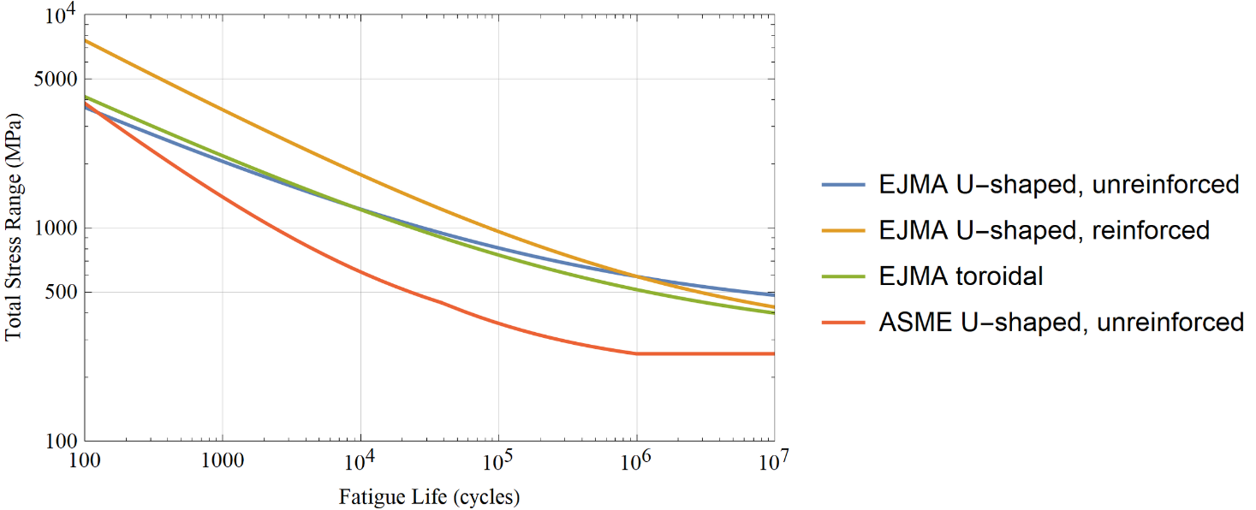
Figure 1 Comparison of Fatigue Curves for Austenitic Stainless Steel:
EJMA-1993 vs ASME-2023
These curves are for austenitic stainless-steel bellows which have not been heat treated and are considered valid primarily in the range of 10³ to 10⁶ cycles.

Bellows (expansion joint)
As an example, consider the LIGO bellows. The CBI calculation of the fatigue life of the LIGO bellows under operating conditions is 13.3k cycles (37 yrs) for diurnal temperature cycling. The same calculation using the latest ASME method yields identical stress amplitudes (total stress range of 1151 MPa or 167 ksi; see Table 3), but a much lower life estimate of 1.6k cycles (4.5 yrs), even with K_{g} = 1. Even if the cycle margin of 2.6 is factored out, the ASME estimate is only 4.2k cycles (12 yrs).
Table 2 LIGO Bellows Movement specified by CBI
Component | Magnitude mm (in)
Axial extension, Xe | 30.7 (1.210)
Axial compression, Xc | 10.9 (0.430)
Lateral, Y | 3.2 (0.125)
Angular, θ | 5.2 mrad (0.300 deg)
Number of convolutions, N | 6
Equivalent axial displacement per convolution, Δqe | 12.6 (0.496)
Note: Lateral and angular deflections cause equivalent axial deflection.

Table 3 LIGO Bellows Stress
Stress Components | CBI/EJMA  (ksi) | ASME  MPa (ksi)
S₃, meridional membrane stress due to pressure | (0.22) | 1.50 (0.22)
S₄, meridional bending stress due to pressure | (4.54) | 31.25 (4.54)
S₅, meridional membrane stress due to the total equivalent axial displacement range Δqe | (1.69) | 11.64 (1.69)
S₆, bending stress due to the total equivalent axial displacement range Δqe | (162.72) | 1116.2 (161.88)
S_{t} = 0.7 (S₃ + S₄) + (S₅ + S₆)  total stress range | (167.74) | 1150.8 (166.90)

One might think that this calculation of the LIGO bellows fatigue life with the latest ASME guidance implies a potentially short life for our installed LIGO bellows – shorter than its operational lifetime to date. However, the diurnal displacement amplitudes used in CBI’s calculation are overly conservative (see Table 2). The diurnal temperature fluctuations to which the LIGO LLO BT is subjected are ~25C. (Perhaps the high desert environment at LHO would result in larger temperature fluctuations, but I don’t have this data.) A 25C diurnal temperature swing results in just 17.2 mm tube expansion (bellows compression) for the 40m length of tube between bellows, as compared to the 41.7 mm total axial displacement assumed by CBI (Xe+Xc from Table 2). The result is a total equivalent displacement of ~70% of the value used by CBI. Using this axial displacement with the ASME method (with K_{g} = 1) results in a predicted fatigue lifetime of 4.1k cycles (11 yrs). If the cycle margin of 2.6 is factored out, the ASME estimate (for 25C diurnal fluctuations) is 10.7k cycles (29 yrs), somewhat similar to the EJMA calculated lifetime. The LIGO beam tube was installed 1997-1998, or ~27 yrs ago.
Since there is conservatism in these lifetime predictions, perhaps a more careful assessment of the diurnal movement (temperature excursions) though the seasons together with finite element analyses of the bellows stresses is in order to get a more accurate assessment of fatigue life. In addition, preemptive preparation for possible leak hunts and bellows leak/crack repairs may be a wise precaution.

Corrugated Tube
A corrugated tube has convolutions similar to a bellows. In essence a cylindrically (or axisymmetric) corrugated tube is an extended bellows. Since the required compression of the convolutions, to compensate for the thermally induced expansion, is distributed across many more convolutions than is the case for a short bellows (expansion joint), one expects the stresses to be quite small and the fatigue life very long. This is indeed the case. Taking GEO600 as an example, the equivalent stress range is only 14 MPa and the fatigue life is > 10⁶ cycles. Infinite fatigue life is one of the benefits of a corrugated tube design.

Stress Corrosion Cracking (SCC)
Stress corrosion cracking results from the combination of a susceptible material, a corrosive chemical species in the operating environment and tensile stress. The tensile stress can be low and can be the applied and/or residual stress (aka built-in or locked-in stress resulting from the forming and welding processes). SCC has a crack initiation phase followed by crack propagation. Relatively little data are available for the crack initiation process.
The following arguments are rather speculative, although I did try to base the estimation on relevant reported data. Consider the following to be a plausibility argument – not a proof, or definitive lifetime prediction – for SCC initiated UHV leaks.
For austenitic stainless steel, the chlorine ion, CL⁻, is one of the most aggressive chemical species. Long term survival is an issue for the nuclear power plant piping and for spent fuel storage. While nuclear power plant applications involve high temperature water (> 200C), dry storage for spent nuclear fuel is potentially in contact with unfiltered sea air with temperatures ranging from 100C to 40C (as the fuel decays). There is unlikely to be a threshold value for stress intensity for SCC propagation (below which SCC would not occur).
Sea water (and air) is a complex mixture of chlorides and sulphates. Transgranular SCC (TGSCC) of 304L exposed to simulated sea air (MgCl₂) showed a temperature threshold for SCC at room temperature and humidity threshold at 30% (27% is the fixed point humidity of MgCl₂, whereas the fixed point humidity of NaCl is 75%)²⁰.
Although CE is likely to be sited in a western US desert environment far from sea air, air does contain small amounts of chlorine. In addition, the soil and any nearby cement structures can leach salts. Concrete contains a variety of soluble mineral salts, both from the cement and from admixtures like calcium chloride, and even from chemicals applied to the concrete after it has hardened. When moisture causes soluble salt within the cement to rise to the surface and form salt deposits (usually white) on or near the surface of the concrete, it is known as efflorescence.
SCC propagation rates for 316L in atmospheric conditions under MgCl₂ deposits (100 microgm/cm^2) at 40C and 40% RH for 1.1 s0.2 (361 MPa) was 1-3 x 10^-11 m/s. For a hypothetical starting crack of a = 0.3 microns, the associated stress intensity factor is only K ≈ 0.35 Mpa-√m. There is also evidence that the crack propagation rate slows as the crack grows in length. This Crack Growth Rate (CGR) is in the same approximate range as for austenitic stainless steel in oxygenated water, as shown in Figure 2.
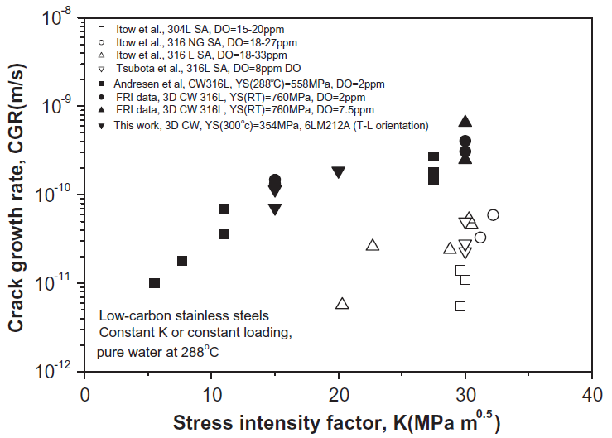
Figure 2 Crack growth rate vs. stress intensity factor for non-sensitized steels in oxygenated pure water at 288C.

Convolution Residual Stresses
Convolutions for formed bellows (as opposed to welded bellows) or corrugated tubes are formed by one of the following four processes:
- Hydroforming
- Punch Forming
- Roll Forming
- Cold Forming
In essence all of these methods are deep-drawing processes and all result in significant residual stresses unless a post-forming stress relief or annealing is performed. The yield strength is also increased by the work hardening which results. According to the 1985 EJMA Standards document (paragraph C-5.15):
“The work hardening of austenitic stainless steel induced during the forming of convolutions generally improves the fatigue life of an expansion joint, often to a marked degree; thus it is not normally considered beneficial to either stress relieve or anneal after forming.”
In principle, post-forming heat treatment could reduce the SCC risk while decreasing the cyclic fatigue lifetime.

Hydroforming
A geometrically and materially nonlinear finite element analysis can be conducted with a 304L material constitutive model to calculate the residual stress distribution. I could not find such an analysis in the literature for a 304L bellows similar to the LIGO bellows, or a convoluted tube similar to what we may contemplate for CE. However, such an analysis was performed for a 0.45 m long x 0.5 m diameter bellows comprised of two layers of Inconel 718 (an austenitic stainless steel) each 1 mm thick, with ten (10) U-shaped convolutions. The FEA results are approximately in agreement with the measured (by x-ray diffraction) residual stress measurement. The peak circumferential tensile stress, for this particular example, is ~600 MPa, at two locations for each convolution (see Figure 3). I suspect that this residual stress scales (roughly) with the material tensile yield stress, which is 1100 MPa for Inconel 718. So, the residual stress for 304L might be ~600 (210/1100) = 115 MPa.
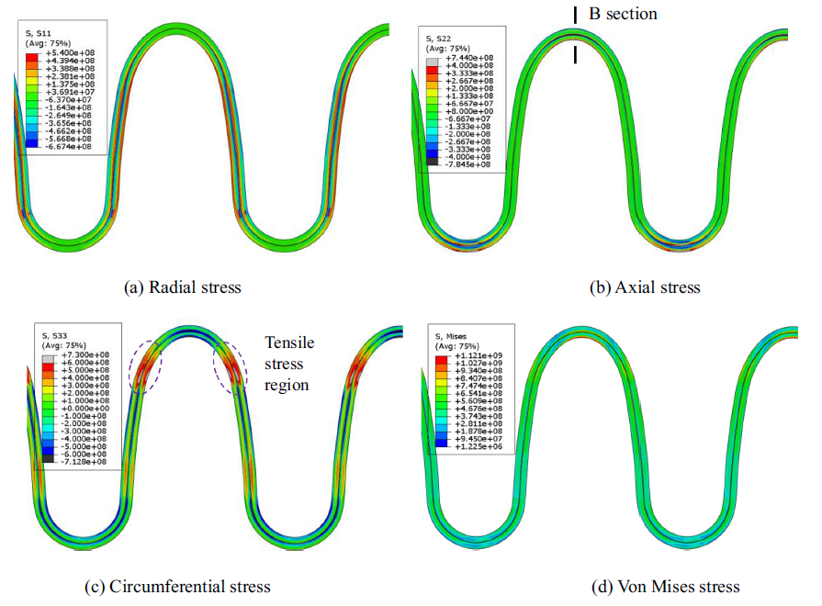
Figure 3 Residual stress distribution²⁵ after hydroforming the bellows (stress unit is Pa)

Welding
Bellows (with a diameter of about 1m) are generally formed into a cylinder with a single longitudinal weld seam, before the convolutions are formed. Convoluted tubes will likewise have weld seams. These seams may be spiral, circumferential or longitudinal. Welding introduces residual stresses including tensile residual stress in the fusion zone (FZ) and in the nearby heat-affected zone (HAZ). As an example, submerged arc welding (SAW) of 304L plate (12.7 mm thick), the measured residual stress at the center of the FZ varies from 100 to 300 MPa and ~150 MPa for the HAZ. Laser welding can reduce the heat input with a resulting decrease in peak residual stress. In addition, use of Low Transformation Temperature Welding wire (LTTW) can induce compressive stresses around 304L welded joints, and improve corrosion resistance.
The CERN CE vacuum team have demonstrated crack formation issues where the corrugation crosses the weld when autogenous TIG welding AISI 430. They have also demonstrated dramatic reduction in grain coarsening and improved formability (for corrugating) when employing autogenous, continuous wave (CW), laser welding of AISI 441. Note that even if the leak failure rate of corrugations formed from AISI 441 with CW laser welding is say 10 times less than for 316L formed by TIG welding, the leak failure rate may be too high for CE.

LIGO Bellows
We leak tested each bellows to ensure that there are no air leaks > 10⁻⁹ Torr-L/s. This serves as a proof test that the maximum crack/hole diameter (through the tube wall thickness) is: a ≤ 0.34 μm (see molecular slip flow calculation). For an applied tensile stress, σ, around the crack/hole, the stress intensity factor is $K_{I}≈σ\sqrt{πa}$. Assuming that σ = total stress range (1151 MPa, see Table 3), then K_{I} = 1.2 MPa-√m. Extrapolating the crack growth rate data in Figure 2 for 316L in pure hydrogenated water at 288C to K_{I} = 1.2, implies a possible crack growth rate of ~2 x 10⁻¹² m/s. For a 3 mm thick shell (like the LIGO tube) this rate of growth would take ~32 years to propagate through the thickness. Note that if we use the atmospheric test data for 316L at 40C and 40% RH, with a 100 microgm/cm^2 deposit of MgCl2 the CGR is ~1 x 10^-11 m/s with a K of only ~0.35 Mpa-√m.
If only the residual tensile circumferential stress (section 7.2.1) is considered (i.e. ignoring any applied operational stress), then for a hypothetical 0.3 micron hole/crack, K ≈ 0.1 MPa-√m.

Microbial Induced Corrosion (MIC)
Microbes in the environment can create a biofilm on the surface of a metal and form anodic (oxidation) and cathodic (reduction) sites which result in electrochemical corrosion, known as Microbially-Induced Corrosion (MIC). This is the mechanism by which multiple UHV leaks resulted in the LIGO LLO Beam Tube. Measures were taken at LLO to significantly mitigate further MIC. The LLO site (and more generally the southeast region of the US) has an environment conducive to MIC. This is not the case for LHO, and more generally the dry/arid western region of the US. Since CE will likely be located in a dry/arid western region of the US, MIC should not be a problem.

Reliability
Forgive me for stating the obvious – Given that the CE beam tubes are 10 times longer than for LIGO, the likelihood of a vacuum system leak failure is roughly 10 times greater (assuming the same materials, construction, design and environment). However, the required (desired) reliability is likely to be higher for CE given the significant cost (downtime for leak hunting) for a 10 times larger facility. This simple fact argues for reliability to be weighted much more highly in design trade-offs than other factors such as cost, manufacturability, ease of assembly, transportability, etc.
While other factors (including cost, but especially speed of fabrication & installation) are important design considerations, we should not lose sight of the fact that long term reliability (order of 50 yrs) is essential.

Conclusions
This superficial estimation of leak failure rate based on accelerator bellows experience, the code book analysis of cyclic fatigue and very approximate estimation of SCC risk, is meant to raise concerns, and not be a definitive analysis (mostly due to lack of sufficient information to perform a convincing analysis).
The EJMA and ASME codes provide proven methods to ensure that our corrugation designs have sufficient cyclic fatigue lifetime (from a structural standpoint and hopefully also for a UHV leak standpoint). We need a similarly robust method to ensure that the SCC lifetime for UHV leaks meets our requirements. This may require (accelerated?) testing of SCC on material coupons in our operational environment.

Recommendations
For CEBEX:
- Have a corrosion expert predict the SCC lifetime for a UHV leak at the 10⁻⁹ Torr-L/s level for environmental/operational conditions applicable to CE (low stress intensity factors, low temperatures and dry desert atmospheric conditions).
  - On the basis of this lifetime prediction, if warranted, perform stressed coupon testing for slow SCC initiation and propagation in atmospheric conditions similar to likely CE site (e.g. Hanford, WA)
- If/as corrugated tube designs are considered, especially if the corrugation shapes are not standard (U or semi-circular):
  - Perform finite element analyses to determine the applied cyclic stresses.
  - Perform nonlinear finite element analyses of the residual stresses from welding and convolution forming.

For LIGO:
- LIGO is already researching the use of ultra-dry air backfill to facilitate BT venting and pumpdown without re-baking; The arguments proposed in this memo support this research.
- Consider performing a more careful assessment of the bellows diurnal movements (temperature excursions) though the seasons together with finite element analyses of the bellows stresses in order to get a more accurate assessment of fatigue life. If a careful analysis indicates that the bellows are somewhat near there predicted fatigue life, then:
  - Consider in situ microscopic examination of the bellows surface near welds and high stress regions, looking for evidence of fatigue cracking or SCC.
  - Preemptively prepare for possible leak hunts and bellows crack repairs or bellows replacements, e.g. determine the suitability criteria for polymers to seal leaks.

Cadwallader, Vacuum Bellows, Vacuum Piping, Cryogenic Break, and Copper Joint Failure Rate Estimates for ITER Design Use, INL/EXT-10-18973, Jun 2010. https://doi.org/10.2172/983360
LEP Vacuum Group, LEP vacuum system: present status, Vacuum, vol 41, issues 7-9, 1990, pg 1882-1886. https://doi.org/10.1016/0042-207X(90)94121-6
Table 2-3 of Reference 1
W. Unterlerchner, “Non-standard vacuum hardware for an accelerator vacuum system,” Vacuum, 41 (1990) 1920-1923.
LIGO-C1900321, LIGO Final Design Review Data Package, Beam Tube Module, File LIGO_DRD_9_ITEM_2.pdf, pg. 257
LIGO-C1900321, Ligo Beam Tube Expansion Joints (construction option), CBI C-EJ-CO, file ligobeamtubemodulebook1of2.pdf, pg. 90-100
LIGO-E950010-00-B, Bellows Design Calculations
CE-CERN Vacuum Studies Group meeting, 20-Nov-2024.
T. Winkel, J. Orchard, Leak evaluation in JET and its consequences for future fusion machines, Vacuum, Volume 41, Issues 7\[Dash]9, 1990, Pages 1988-1991, ISSN 0042-207X. https://doi.org/10.1016/0042-207X(90)94153-H
C Affeldt, et. al., Advanced techniques in GEO 600, 2014 Class. Quantum Grav. 31 224002. DOI 10.1088/0264-9381/31/22/224002
A. Magesh, U. Ganesan, R. Sundararajan, Key parameters that affect the fatigue life of metal bellows-type expansion joint: Another look, Materials Today Communications, 38 (2024), 108400
Standards of the Expansion Joint Manufacturers Association (EJMA), 6th edition, 1993. (Note: The latest version is the 10th edition, but I currently only have a copy of the 6th edition.)
ASME Boiler and Pressure Vessel Code, Section VIII: Rules for Construction of Pressure Vessels, Division 2: Alternative Rules, 2023 edition, ASME BPVC.VIII.2-2023, Part 4.19: Design Rules for Bellows Expansion Joints.
J. Johnson, Bellows design calculations, LIGO-E950010 , pg. 2
See the Mathematica notebook “convolution fatigue lifetime” uploaded with this technical note to the LIGO DCC.
CBI, LIGO Beam Tube Expansion Joints: Construction Option, document C-EJ-CO, section 3.7.1: Maximum movements, operating, 3/1994, found on pg. 94 of file “ligobeamtubemodulebook1of2.pdf” files at https://dcc.ligo.org/LIGO-C1900321
see section 6.1.1.2 of LIGO-T2000475-v1
See the Mathematica notebook “convolution fatigue lifetime” uploaded with this technical note to the LIGO DCC.
L. Chang, et. al., Effect of maching on stress corrosion crack initiation in warm-forged type 304L stainless steel in high temperature water, Volume 165, 15 February 2019, Pages 203-214. https://doi.org/10.1016/j.actamat.2018.11.046
D.T.Spencer, et.al., The initiation and propagation of chloride-induced transgranular stress-corrosion cracking (TGSCC) of 304L austenitic stainless steel under atmospheric conditions, Corrosion Science, 88 (2014), 76-88.
Y. Zhang, et. al., Atmospheric stress corrosion crack growth rates of 316 L stainless steel for nuclear waste containment, Corrosion Science 177 (2020) 109008
Sensitization in austenitic steel refers to making steel more susceptible to corrosion by its processing. This is usually a result of welding or by subjecting it to certain heat treatments (such as high-temperature for extended periods of time, or rapid cooling).
Z. Lu et.al., Effects of water chemistry and loading conditions on stress corrosion cracking of cold-rolled 316NG stainless steel in high temperature water, Corrosion Science, 53 (2011), 247-262.
https://www.triadbellows.com/4-manufacturing-methods-of-metal-bellows/
J. Lin, et. al., Residual stress analysis and measurement in multi-layer bellows, Journal of Manufacturing Processes 72 (2021) 179–194
Tang,W.; Chatzidakis, S.; Schrad, C.M.; Miller, R.G.; Howard, R. Study of Mechanical Properties, Microstructure, and Residual Stresses of AISI 304/304L Stainless Steel Submerged ArcWeld for Spent Fuel Dry Storage Systems. Metals 2024, 14, 262. https://doi.org/10.3390/met14030262
L.Y.Xu, et. al., Fatigue strength improvement of stainless steel using weld toes dressing with low transformation temperature welding wire, Volume 19, Issue 8, https://doi.org/10.1179/1362171814Y.0000000240
Z. Wang, Development of LTTW consumables for the enhancement of mechanical properties and residual stress management in thin steel welded joints, Colorado School of Mines, Dissertation, 2016. 10244804.
S. Zhao, et. al., Electrochemical Behavior of Welded Joints with 308L Stainless Welding Wire and Low Temperature Transformation Welding Wire, Advanced Materials Research, ISSN: 1662-8985, Vols. 418-420, pp 1392-1395
M. Dakshinamurthy and A. T. Pérez, CERN, Materials and manufacturing for the pilot sector, 22 Jan 2024
M.R.Prisco, et. al., Predictions of Vacuum Loss of Evacuated Vials from Initial Air Leak Rates, Journal of Pharmaceutical Sciences, volume 102, issue 8, Aug 2013, pp. 2730-2737. https://doi.org/10.1002/jps.23652; see also the calculation in the Mathematica notebook uploaded with this technical note to the LIGO DCC.
e.g. https://engineeringlibrary.org/reference/fracture-mechanics-stress-intensity-factor
D. Henkel, Attack of Stainless Steel Beam Tube - Microbially-Induced Corrosion, Jan-2019, LIGO-G2000867

