LASER INTERFEROMETER GRAVITATIONAL WAVE OBSERVATORY

-LIGO-

**CALIFORNIA INSTITUTE OF TECHNOLOGY** **MASSACHUSETTS INSTITUTE OF TECHNOLOGY**

|  |  |  |
| --- | --- | --- |
| Document Type  Test Procedure | DCC Number  **T2500269-v1** | June 29th, 2025 |
| **PZT Driver Chassis Test Procedure** | | |
| D. Sigg | | |

Distribution of this draft:

This is an internal working note of the LIGO Laboratory

# California Institute of Technology Massachusetts Institute of Technology LIGO Project – MS 18-33 LIGO Project – MS 20B-145 Pasadena, CA 91125 Cambridge, MA 01239

Phone (626) 395-2129 Phone (617) 253-4824

Fax (626) 304-9834 Fax (617) 253-7014

E-mail: [info@ligo.caltech.edu](mailto:info@ligo.caltech.edu) E-mail: [info@ligo.mit.edu](mailto:info@ligo.mit.edu)

<http://www.ligo.caltech.edu/>

Performed by: Date:

Board Serial Number:

# Overview

The PZT Driver Chassis ([D2500193](https://dcc.ligo.org/LIGO-D2500193)) houses two PZT Driver Boards ([D1001203-v3](https://dcc.ligo.org/LIGO-D1001203)), one PZT Driver Interface Board ([D1001204-v1](https://dcc.ligo.org/LIGO-D1001204)), one ISC Mixed Whitening/Dewhitening Board ([D2500135-v1](https://dcc.ligo.org/LIGO-D2500135)), one PZT Driver Dewhitening Interface Board ([D2500196-v1](https://dcc.ligo.org/LIGO-D2500196)), and one Low Noise Power Board ([D0901846-v5](https://dcc.ligo.org/LIGO-D0901846)) The function of this chassis is to drive 2 PZTs. Analog dewhitening filters are provided for the PZTs. 2 channels of whitening are available for other purposes.

# Test Equipment

* 1. Digital I/O Tester, D1200297-v1
  2. Power Supply capable of ±17V
  3. Power Supply capable of ±24V
  4. Power Supply capable of +400V (For the “HV” connector)
  5. Voltage Calibrator, or adjustable power supply
  6. SR785 Network Analyzer, or equivalent
  7. 1 Dsub Breakout boards (15-pin)
  8. 1 Dsub cable (37-pin M-F)
  9. Digital Multimeter (DMM)
  10. Oscilloscope

# Preliminaries

* 1. Perform visual inspection of the Chassis to make sure nothing looks overtly broken.
  2. First time power up: Set the output voltage to zero and connect the power supplies to the chassis. Slowly turn up the 24V supplies. Make sure it doesn’t draw too much current. Repeat for the 17V supplies. Repeat for the 400V supply. Then, turn the 400V supply off and remove,
  3. For the start of the test procedure, use a +24V supply instead of the high voltage.
  4. Next power ups: Before connecting the power to the box, set all power supplies to their correct Voltages and then turn them off. Connect the power supply to the chassis under test at the appropriate connectors. Turn on the 24V, then the 17V, then the High Voltage (24V at beginning of test) supply.
  5. Connect 15-pin Dsub Breakout boards to the “Controls” connector on the back panel, and connect the 37-pin cable between the digital IO tester and the “Dewhitening Controls ”connector on the front panel.

# Basic Electrical Tests

*To test the Low Noise Power Module (D0901846) with the PZT Driver Interface (D1001204).*

* 1. **Verify the proper current draw.** Using a bench DC supply apply ±24Volts to P7 and

±17 Volts to P6 of the low noise power Module (D0901846). Measure the current draw of the board.

+24 Volt current ______________ 30mA Nom.

–24 Volt current ______________ 30mA Nom.

+17 Volt current ______________ less than 300mA

–17 Volt current ______________ less than 300mA

* 1. **On the low noise power module check the voltage on TP 1-13.**

TP1 ( +17V ) ______________ TP2 (–17V ) ______________

TP3 , 4 ( GND ) TP5 (+ 5V) ______________

TP6 (–15V ) ______________ TP7 (+24V ) ______________

TP8 ( GND ) TP9 (–24V ) ______________

TP10 ( GND ) TP11 (+15V ) ______________

TP12 (+VREF ) ______________ TP13 (–VREF ) ______________

* 1. **If TP 1 , 2, 7 , 9 and 8 are correct then pin 5 on U1 and U7, TP14 (OK) should be Logic high ~3Volts. The front panel LED should be on.**

Confirm

* 1. **The noise on TP 12, 13, 11 and 6 should be measured with a SR785 using an rms power spectrum.**

TP12 noise ____________________ less than 20 nVrms/√Hz at 140 Hz

TP13 noise ____________________ less than 30 nVrms/√Hz at 140 Hz

TP11 noise ____________________ less than 40 nVrms/√Hz at 140 Hz

TP6 noise ____________________ less than 60 nVrms/√Hz at 140 Hz.

* 1. **On the ISC Mixed Whitening Board check the voltages**

TP3 ( +15V ) ______________ TP6 (–15V ) ______________

* 1. **On the 2 PZT driver boards check the voltages**

Board 1:

TP6 ( +15V ) ______________ TP8 (–15V ) ______________

Board 2:

TP6 ( +15V ) ______________ TP8 (–15V ) ______________

* 1. **Check power OKs**

Temporarily switch to the +400V supply for the HV. Turn the voltage to zero. Measure at the rear Controls connector between pins 15 & 8. It should be near zero volt.

Confirm

Turn the HV supply slowly up. Roughly around +300V the measured signal should switch to +5V. Make sure that above 325V the signal is +5V.

Confirm

Switch the HV supply back to +24V.

# Whitening/Dewhitening Tests

Dewhitening: Using an SR785 (or automated test setup), take a transfer function for each of the 2 dewhitening channels associated with the front panel Analog Signal Input (IN1/IN2) and test points TP7/TP9 on the ISC Mixed Whitening/Dewhitening Board channels 1 & 2.

Whitening: Using an SR785 (or automated test setup), take a transfer function for each of the 2 whitening channels associated with the front panel Analog Signal Input (IN3/IN4) and front panel Analog Signal Output (OUT3/OUT4).

# Transfer Function Tests

For each channel, verify the transfer functions are in conformance with the following data. There’s a lot of gain in this unit for some combinations of filters and gain, so use care with the analyzer source drive setting. At the highest gain setting, “Everything On”, use 0.1mV source drive on the SR785. At lower gains, between 1mV and 10mV are acceptable. For dewhitening channels even higher levels are required since the gain is smaller than 1.

**Table 1**: **Whitening Transfer Function Predicted Data**

|  |  |  |  |  |
| --- | --- | --- | --- | --- |
| **Gain State** | **Gain** | **Phase** | **Gain** | **Phase** |
| **at 10** **Hz** | | **at 1** **kHz** | |
| 0 dB | 0 dB ± 1 dB | 0° ± 3° | 0 dB ± 1 dB | -7° ± 3° |
| 3 dB | 3 dB ± 1 dB | 0° ± 3° | 3 dB ± 1 dB | -7° ± 3° |
| 6 dB | 6 dB ± 1 dB | 0° ± 3° | 6 dB ± 1 dB | -7° ± 3° |
| 12 dB | 12 dB ± 1 dB | 0° ± 3° | 12 dB ± 1 dB | -7° ± 3° |
| 24 dB | 24 dB ± 1 dB | 0° ± 3° | 24 dB ± 1 dB | -7° ± 3° |
| 45 dB (all DC gain) | 45 dB ± 1 dB | 0° ± 3° | 45 dB ± 1 dB | -7° ± 3° |
| 1st Filter only | 17 dB ± 1 dB | 39° ± 3° | 20 dB ± 1 dB | -7° ± 3° |
| 1st & 2nd Filter | 35 dB ± 1 dB | 79° ± 3° | 41 dB ± 1 dB | -7° ± 3° |
| 1st, 2nd & 3rd Filter | 52 dB ± 1 dB | 118° ± 3° | 61 dB ± 1 dB | -7° ± 3° |
| Everything On | 97 dB ± 1 dB | 119° ± 3° | 106 dB ± 1 dB | -8° ± 3° |

**Table 2**: **Dewhitening Transfer Function Predicted Data**

|  |  |  |  |  |
| --- | --- | --- | --- | --- |
| **Gain State** | **Gain** | **Phase** | **Gain** | **Phase** |
| **at 10** **Hz** | | **at 1** **kHz** | |
| 0 dB | 0 dB ± 1 dB | 0° ± 3° | 0 dB ± 1 dB | -7° ± 3° |
| 3 dB | −3 dB ± 1 dB | 0° ± 3° | −3 dB ± 1 dB | -7° ± 3° |
| 6 dB | −6 dB ± 1 dB | 0° ± 3° | 6 dB ± 1 dB | -7° ± 3° |
| 12 dB | −12 dB ± 1 dB | 0° ± 3° | −12 dB ± 1 dB | -7° ± 3° |
| 24 dB | −24 dB ± 1 dB | 0° ± 3° | −24 dB ± 1 dB | -7° ± 3° |
| 45 dB (all DC gain) | −45 dB ± 1 dB | 0° ± 3° | −45 dB ± 1 dB | -7° ± 3° |
| 1st Filter only | −17 dB ± 1 dB | −39° ± 3° | −20 dB ± 1 dB | -7° ± 3° |
| 1st & 2nd Filter | −35 dB ± 1 dB | −79° ± 3° | −41 dB ± 1 dB | -7° ± 3° |
| 1st, 2nd & 3rd Filter | −52 dB ± 1 dB | −118° ± 3° | −61 dB ± 1 dB | -7° ± 3° |
| Everything On | −97 dB ± 1 dB | −119° ± 3° | −106 dB ± 1 dB | -8° ± 3° |

**Measured Data Ch1:**

|  |  |  |  |  |
| --- | --- | --- | --- | --- |
| **Gain State** | **Gain** | **Phase** | **Gain** | **Phase** |
| **at 10** **Hz** | | **at 1** **kHz** | |
| 0 dB |  |  |  |  |
| 3 dB |  |  |  |  |
| 6 dB |  |  |  |  |
| 12 dB |  |  |  |  |
| 24 dB |  |  |  |  |
| 45 dB (all DC gain) |  |  |  |  |
| 1st Filter only |  |  |  |  |
| 1st & 2nd Filter |  |  |  |  |
| 1st, 2nd & 3rd Filter |  |  |  |  |
| Everything On |  |  |  |  |

**Measured Data Ch2:**

|  |  |  |  |  |
| --- | --- | --- | --- | --- |
| **Gain State** | **Gain** | **Phase** | **Gain** | **Phase** |
| **at 10** **Hz** | | **at 1** **kHz** | |
| 0 dB |  |  |  |  |
| 3 dB |  |  |  |  |
| 6 dB |  |  |  |  |
| 12 dB |  |  |  |  |
| 24 dB |  |  |  |  |
| 45 dB (all DC gain) |  |  |  |  |
| 1st Filter only |  |  |  |  |
| 1st & 2nd Filter |  |  |  |  |
| 1st, 2nd & 3rd Filter |  |  |  |  |
| Everything On |  |  |  |  |

**Measured Data Ch3:**

|  |  |  |  |  |
| --- | --- | --- | --- | --- |
| **Gain State** | **Gain** | **Phase** | **Gain** | **Phase** |
| **at 10** **Hz** | | **at 1** **kHz** | |
| 0 dB |  |  |  |  |
| 3 dB |  |  |  |  |
| 6 dB |  |  |  |  |
| 12 dB |  |  |  |  |
| 24 dB |  |  |  |  |
| 45 dB (all DC gain) |  |  |  |  |
| 1st Filter only |  |  |  |  |
| 1st & 2nd Filter |  |  |  |  |
| 1st, 2nd & 3rd Filter |  |  |  |  |
| Everything On |  |  |  |  |

**Measured Data Ch4:**

|  |  |  |  |  |
| --- | --- | --- | --- | --- |
| **Gain State** | **Gain** | **Phase** | **Gain** | **Phase** |
| **at 10** **Hz** | | **at 1** **kHz** | |
| 0 dB |  |  |  |  |
| 3 dB |  |  |  |  |
| 6 dB |  |  |  |  |
| 12 dB |  |  |  |  |
| 24 dB |  |  |  |  |
| 45 dB (all DC gain) |  |  |  |  |
| 1st Filter only |  |  |  |  |
| 1st & 2nd Filter |  |  |  |  |
| 1st, 2nd & 3rd Filter |  |  |  |  |
| Everything On |  |  |  |  |

# Noise Spectra Tests

For each channel, verify the noise spectra are in conformance with the following data. Shorten the inputs to ground for this test.

**Table 3**: **Noise Predictions**

|  |  |  |  |  |
| --- | --- | --- | --- | --- |
| **Gain State** | **Noise ( dBVrms/√Hz)** | | | |
| **Whitening** | | **Dewhitening** | |
| **at 10** **Hz** | **at 1** **kHz** | **at 10** **Hz** | **at 1** **kHz** |
| 0 dB | −148 ± 2 dB | −150 ± 2 dB | −148 ± 2 dB | −150 ± 2 dB |
| 3 dB | −147 ± 2 dB | −148 ± 2 dB | −149 ± 2 dB | −152 ± 2 dB |
| 9 dB | −142 ± 2 dB | −143 ± 2 dB | −156 ± 2 dB | −156 ± 2 dB |
| 12 dB | −130 ± 2 dB | −132 ± 2 dB | −156± 2 dB | −156 ± 2 dB |
| 24 dB | −118 ± 2 dB | −110 ± 2 dB | −156 ± 2 dB | −156 ± 2 dB |
| 45 dB | −107 ± 2 dB | −107 ± 2 dB | −156 ± 2 dB | −156 ± 2 dB |
| 1st Filter only | −133 ± 2 dB | −132 ± 2 dB | −156 ± 2 dB | −156 ± 2 dB |
| 1st & 2nd Filter | −115 ± 2 dB | −112 ± 2 dB | −156 ± 2 dB | −156 ± 2 dB |
| 1st, 2nd & 3rd Filter | −97 ± 2 dB | −91 ± 2 dB | −156 ± 2 dB | −156 ± 2 dB |
| Everything On | −53 ± 2 dB | −46 ± 2 dB | −156 ± 2 dB | −156 ± 2 dB |

**Measured Data Ch1:**

|  |  |  |  |  |
| --- | --- | --- | --- | --- |
| **Gain State** | **Noise** | | | |
| **Whitening** | | **Dewhitening** | |
| **10** **Hz** | **1** **kHz** | **10** **Hz** | **1** **kHz** |
| 0 dB |  |  |  |  |
| 3 dB |  |  |  |  |
| 6 dB |  |  |  |  |
| 12 dB |  |  |  |  |
| 24 dB |  |  |  |  |
| 45 dB (all DC gain) |  |  |  |  |
| 1st Filter only |  |  |  |  |
| 1st & 2nd Filter |  |  |  |  |
| 1st, 2nd & 3rd Filter |  |  |  |  |
| Everything On |  |  |  |  |

**Measured Data Ch2:**

|  |  |  |  |  |
| --- | --- | --- | --- | --- |
| **Gain State** | **Noise** | | | |
| **Whitening** | | **Dewhitening** | |
| **10** **Hz** | **1** **kHz** | **10** **Hz** | **1** **kHz** |
| 0 dB |  |  |  |  |
| 3 dB |  |  |  |  |
| 6 dB |  |  |  |  |
| 12 dB |  |  |  |  |
| 24 dB |  |  |  |  |
| 45 dB (all DC gain) |  |  |  |  |
| 1st Filter only |  |  |  |  |
| 1st & 2nd Filter |  |  |  |  |
| 1st, 2nd & 3rd Filter |  |  |  |  |
| Everything On |  |  |  |  |

**Measured Data Ch3:**

|  |  |  |  |  |
| --- | --- | --- | --- | --- |
| **Gain State** | **Noise** | | | |
| **Whitening** | | **Dewhitening** | |
| **10** **Hz** | **1** **kHz** | **10** **Hz** | **1** **kHz** |
| 0 dB |  |  |  |  |
| 3 dB |  |  |  |  |
| 6 dB |  |  |  |  |
| 12 dB |  |  |  |  |
| 24 dB |  |  |  |  |
| 45 dB (all DC gain) |  |  |  |  |
| 1st Filter only |  |  |  |  |
| 1st & 2nd Filter |  |  |  |  |
| 1st, 2nd & 3rd Filter |  |  |  |  |
| Everything On |  |  |  |  |

**Measured Data Ch4:**

|  |  |  |  |  |
| --- | --- | --- | --- | --- |
| **Gain State** | **Noise** | | | |
| **Whitening** | | **Dewhitening** | |
| **10** **Hz** | **1** **kHz** | **10** **Hz** | **1** **kHz** |
| 0 dB |  |  |  |  |
| 3 dB |  |  |  |  |
| 6 dB |  |  |  |  |
| 12 dB |  |  |  |  |
| 24 dB |  |  |  |  |
| 45 dB (all DC gain) |  |  |  |  |
| 1st Filter only |  |  |  |  |
| 1st & 2nd Filter |  |  |  |  |
| 1st, 2nd & 3rd Filter |  |  |  |  |
| Everything On |  |  |  |  |

# PZT Driver Tests

Make sure that the HV voltage is only +24V before starting this test! Set the dewhitening settings to 0dB without any filters on.

# PZT Transfer Function Tests

Take the transfer function from the appropriate channel “IN” TNC connector to the back panel “Output” connector, or the front panel “MON” connector, or the front panel “OUT” connector as directed in the table below. Set the source to 200mV, and sweep from 0.1Hz to 100KHz, with 61 steps. The traces should look like the simulation example given. Record the amplitude at the frequency of each column. Passing values are nominal± 0.2 dB, except for 100KHz, which can be ± 1 dB.

**To back Panel “Output” connector:**

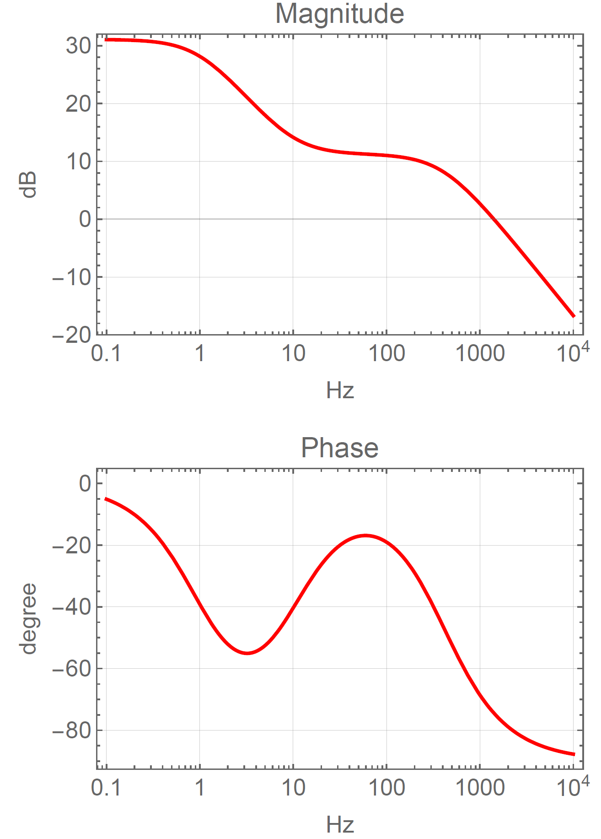

|  |  |  |  |  |  |  |  |  |
| --- | --- | --- | --- | --- | --- | --- | --- | --- |
| Connector | Offset Pins | 0.1 Hz  (31.0 dB) | 1 Hz  (28.2 dB) | 10 Hz  (14.2 dB) | 100 Hz (11.0 dB) | 1 kHz (2.7 dB) | 10 kHz (−16 .7dB) | 100 kHz  (−36.7 dB) |
| Ch1 | 1(-), 9(+) |  |  |  |  |  |  |  |
| Ch2 | 2(-), 10(+) |  |  |  |  |  |  |  |

**To Front Panel “MON” connector:**

|  |  |  |
| --- | --- | --- |
| Channel | 1 Hz  (−0.3 dB) | 1 kHz  (−2.0 dB) |
| Ch1 |  |  |
| Ch2 |  |  |

* 1. **PZT Noise Tests**

With the inputs to the PZT Drivers shorted together, and grounded, read the output noise levels on the appropriate “OUT” channels. Span the analyzer down to a 400Hz bandwidth. Fill out the appropriate cells in the table below:

|  |  |
| --- | --- |
| Outputs | Level @ 100Hz (nom. below 120nV/√Hz) |
| Ch1 |  |
| Ch2 |  |

* 1. **PZT Offset Tests**

Switch to the HV supply and set to 400V.

Use the voltage calibrator to add a voltage to the rear “Controls” connector and measure the PZT output signal with a DVM. Make sure the offset can be adjusted from –10V to +350V. The required offsets should be around –0.25V for a –10V output, and +10V for a +350V output. Use pins 1/9 for Ch1, and 2/10 for Ch2.

Confirm Ch1 Ch2